**Configuration del framework express desde CMD**

Microsoft Windows [Versión 6.1.7601]

Copyright (c) 2009 Microsoft Corporation. Reservados todos los derechos.

C:\Users\homero>C:\Users\homero\Desktop\Crudnodejs

"C:\Users\homero\Desktop\Crudnodejs" no se reconoce como un comando interno o ex

terno,

programa o archivo por lotes ejecutable.

C:\Users\homero>cd C:\Users\homero\Desktop\Crudnodejs

C:\Users\homero\Desktop\Crudnodejs>npm install express-generator -g

C:\Users\homero\AppData\Roaming\npm\express -> C:\Users\homero\AppData\Roaming\n

pm\node_modules\express-generator\bin\express

C:\Users\homero\AppData\Roaming\npm

`-- express-generator@4.13.4

C:\Users\homero\Desktop\Crudnodejs>express crudnodejs

create : crudnodejs

create : crudnodejs/package.json

create : crudnodejs/app.js

create : crudnodejs/public

create : crudnodejs/public/javascripts

create : crudnodejs/public/images

create : crudnodejs/public/stylesheets

create : crudnodejs/public/stylesheets/style.css

create : crudnodejs/routes

create : crudnodejs/routes/index.js

create : crudnodejs/routes/users.js

create : crudnodejs/views

create : crudnodejs/views/index.jade

create : crudnodejs/views/layout.jade

create : crudnodejs/views/error.jade

create : crudnodejs/bin

create : crudnodejs/bin/www

install dependencies:

> cd crudnodejs && npm install

run the app:

> SET DEBUG=crudnodejs:* & npm start

C:\Users\homero\Desktop\Crudnodejs>cd crudnodejs

C:\Users\homero\Desktop\Crudnodejs\crudnodejs>npm install

npm WARN deprecated jade@1.11.0: Jade has been renamed to pug, please install th

e latest version of pug instead of jade

npm WARN deprecated transformers@2.1.0: Deprecated, use jstransformer

crudnodejs@0.0.0 C:\Users\homero\Desktop\Crudnodejs\crudnodejs

+-- body-parser@1.15.2

| +-- bytes@2.4.0

| +-- content-type@1.0.2

| +-- depd@1.1.0

| +-- http-errors@1.5.0

| | +-- inherits@2.0.1

| | +-- setprototypeof@1.0.1

| | `-- statuses@1.3.0

| +-- iconv-lite@0.4.13

| +-- on-finished@2.3.0

| | `-- ee-first@1.1.1

| +-- qs@6.2.0

| +-- raw-body@2.1.7

| | `-- unpipe@1.0.0

| `-- type-is@1.6.13

| +-- media-typer@0.3.0

| `-- mime-types@2.1.12

| `-- mime-db@1.24.0

+-- cookie-parser@1.4.3

| +-- cookie@0.3.1

| `-- cookie-signature@1.0.6

+-- debug@2.2.0

| `-- ms@0.7.1

+-- express@4.13.4

| +-- accepts@1.2.13

| | `-- negotiator@0.5.3

| +-- array-flatten@1.1.1

| +-- content-disposition@0.5.1

| +-- cookie@0.1.5

| +-- escape-html@1.0.3

| +-- etag@1.7.0

| +-- finalhandler@0.4.1

| +-- fresh@0.3.0

| +-- merge-descriptors@1.0.1

| +-- methods@1.1.2

| +-- parseurl@1.3.1

| +-- path-to-regexp@0.1.7

| +-- proxy-addr@1.0.10

| | +-- forwarded@0.1.0

| | `-- ipaddr.js@1.0.5

| +-- qs@4.0.0

| +-- range-parser@1.0.3

| +-- send@0.13.1

| | +-- destroy@1.0.4

| | +-- http-errors@1.3.1

| | +-- mime@1.3.4

| | `-- statuses@1.2.1

| +-- serve-static@1.10.3

| | `-- send@0.13.2

| | +-- http-errors@1.3.1

| | `-- statuses@1.2.1

| +-- utils-merge@1.0.0

| `-- vary@1.0.1

+-- jade@1.11.0

| +-- character-parser@1.2.1

| +-- clean-css@3.4.20

| | +-- commander@2.8.1

| | | `-- graceful-readlink@1.0.1

| | `-- source-map@0.4.4

| | `-- amdefine@1.0.0

| +-- commander@2.6.0

| +-- constantinople@3.0.2

| | `-- acorn@2.7.0

| +-- jstransformer@0.0.2

| | +-- is-promise@2.1.0

| | `-- promise@6.1.0

| | `-- asap@1.0.0

| +-- mkdirp@0.5.1

| | `-- minimist@0.0.8

| +-- transformers@2.1.0

| | +-- css@1.0.8

| | | +-- css-parse@1.0.4

| | | `-- css-stringify@1.0.5

| | +-- promise@2.0.0

| | | `-- is-promise@1.0.1

| | `-- uglify-js@2.2.5

| | +-- optimist@0.3.7

| | | `-- wordwrap@0.0.3

| | `-- source-map@0.1.43

| +-- uglify-js@2.7.4

| | +-- async@0.2.10

| | +-- source-map@0.5.6

| | +-- uglify-to-browserify@1.0.2

| | `-- yargs@3.10.0

| | +-- camelcase@1.2.1

| | +-- cliui@2.1.0

| | | +-- center-align@0.1.3

| | | | +-- align-text@0.1.4

| | | | | +-- kind-of@3.0.4

| | | | | | `-- is-buffer@1.1.4

| | | | | +-- longest@1.0.1

| | | | | `-- repeat-string@1.6.1

| | | | `-- lazy-cache@1.0.4

| | | +-- right-align@0.1.3

| | | `-- wordwrap@0.0.2

| | +-- decamelize@1.2.0

| | `-- window-size@0.1.0

| +-- void-elements@2.0.1

| `-- with@4.0.3

| +-- acorn@1.2.2

| `-- acorn-globals@1.0.9

+-- morgan@1.7.0

| +-- basic-auth@1.0.4

| `-- on-headers@1.0.1

`-- serve-favicon@2.3.0

C:\Users\homero\Desktop\Crudnodejs\crudnodejs>

C:\Users\homero\Desktop\Crudnodejs\crudnodejs>set debug = crudnodejs:*&npm start

> crudnodejs@0.0.0 start C:\Users\homero\Desktop\Crudnodejs\crudnodejs

> node ./bin/www

GET / 200 670.460 ms - 170

GET /stylesheets/style.css 200 8.657 ms - 111

GET /favicon.ico 404 47.444 ms - 1265

Forma de instalar la dependencia de mysql, hay que tener encuenta estar en la carpeta del Proyecto como lo muestra el siguiente print

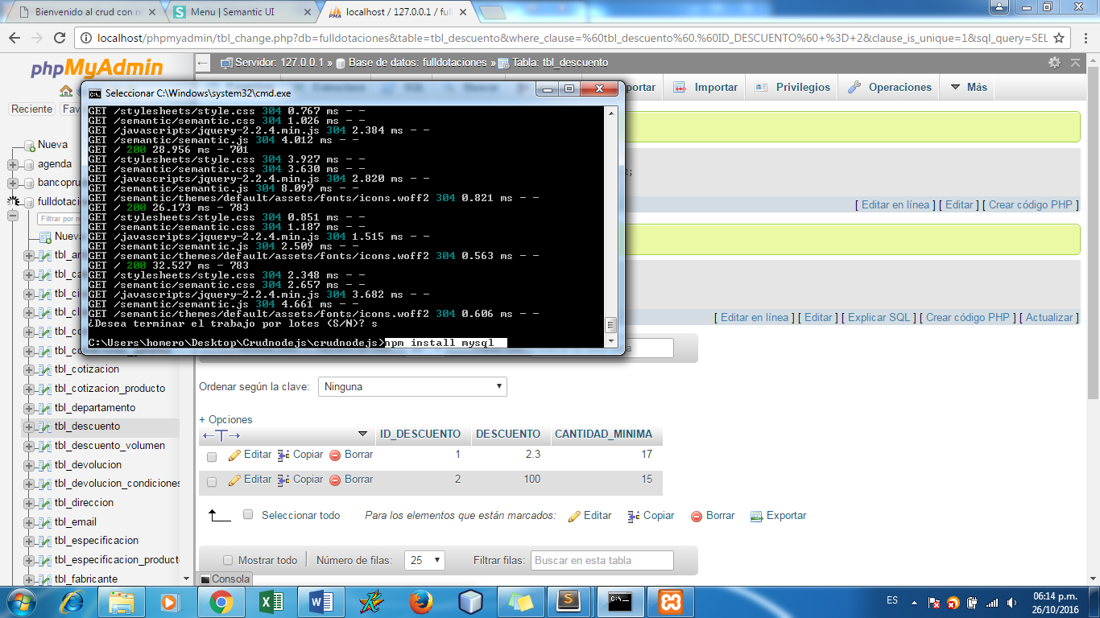

Luego nos dirigimos a módulos de node como l muestra la imagen y observamos que ya mysql está incorporado

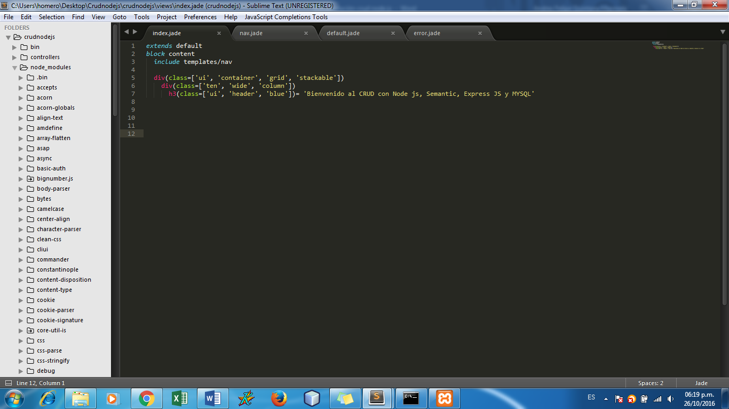

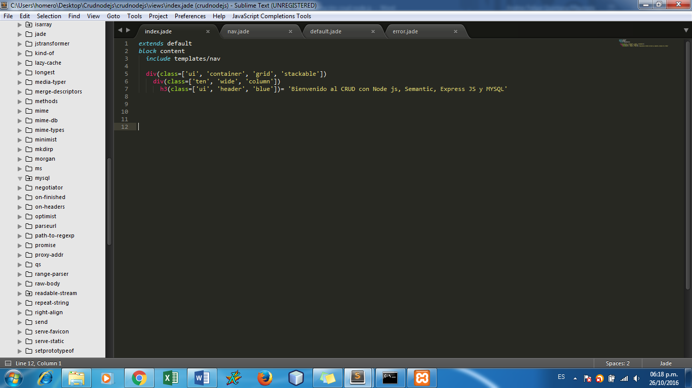

Instalación de la dependencia para trabajar con fechas, hay que tener en cuenta que se debe estar en la carpeta raíz del proyecto como lo muestra el siguiente print

